**Books Every Software Tester**

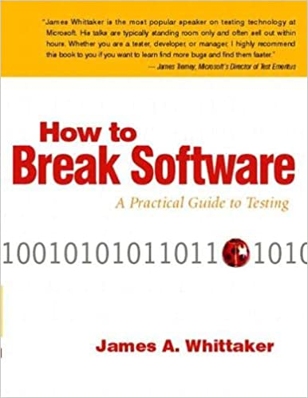

"How to Break Software: A Practical Guide to Testing" by James A. Whittaker - A classic book on software testing that offers practical tips and techniques for breaking software and finding bugs.

Buy here - <https://amzn.to/3HZlist>

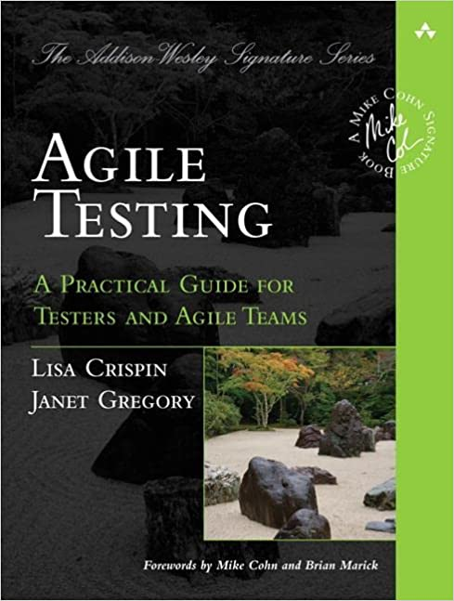

"Agile Testing: A Practical Guide for Testers and Agile Teams" by Lisa Crispin and Janet Gregory - This book provides guidance on how to apply testing in an Agile environment, including Agile testing principles and practices.

"Exploratory Software Testing: Tips, Tricks, Tours, and Techniques to Guide Test Design" by James A. Whittaker - This book explores the benefits of exploratory testing and offers a variety of techniques for designing and conducting effective exploratory tests.

Buy Link - <https://amzn.to/3YKLDkU>

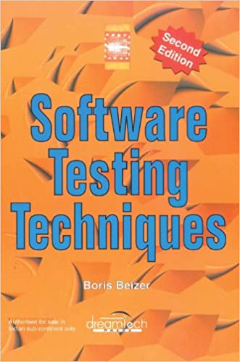

"Software Testing Techniques, 2nd Edition" by Boris Beizer - This book covers a wide range of software testing techniques and methods, including black-box testing, white-box testing, and more.

Buy Link - <https://amzn.to/3lyasCq>

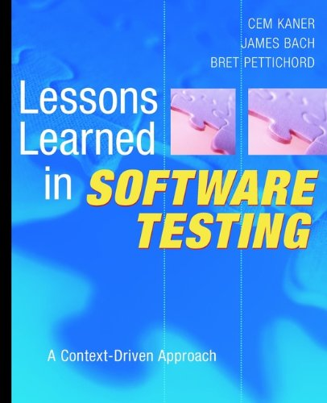

"Lessons Learned in Software Testing: A Context-Driven Approach" by Cem Kaner, James Bach, and Bret Pettichord - This book provides practical advice on software testing based on real-world experience, including strategies for designing effective tests, managing test teams, and more.

Buy Link - <https://amzn.to/3S3PLdO>